**SQL BASICS**

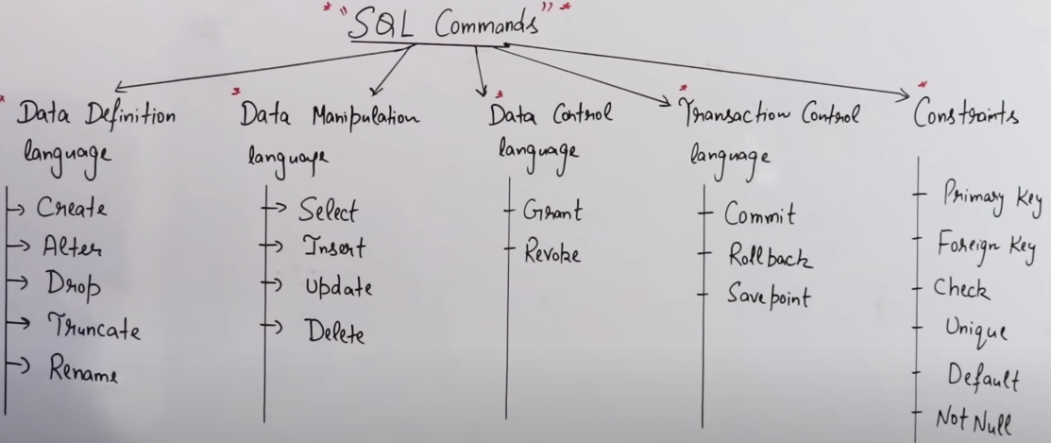

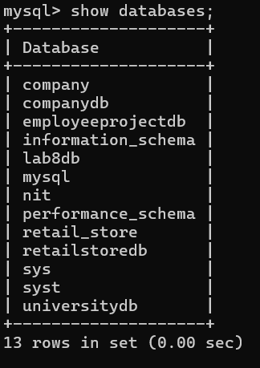

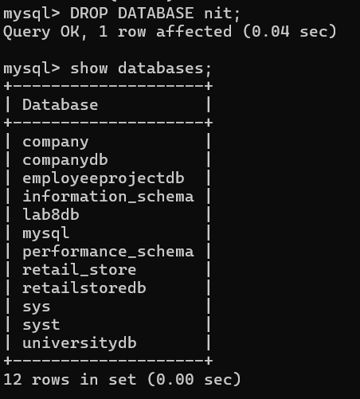

**Create database nit:**

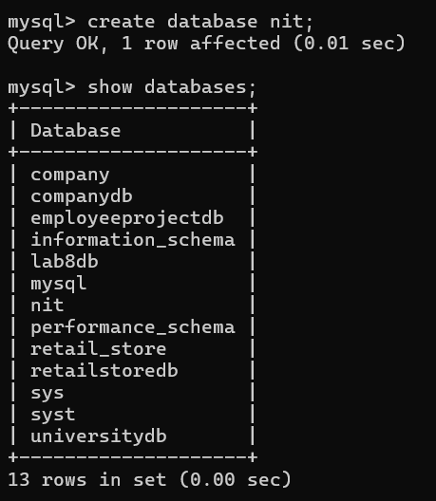

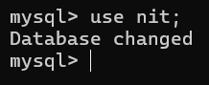

**create nit db – use nit db –**

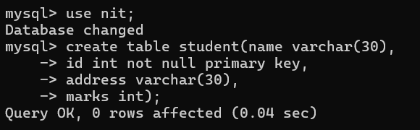**create student table with column ( name, id is not null and also ID will be the primary key, address, marks) – for describe the table use desc**

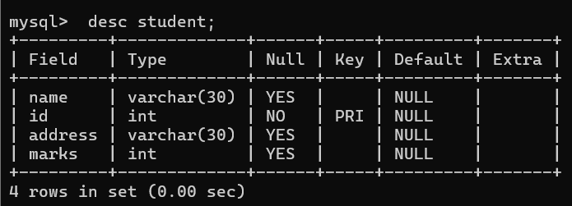

**Once table created then we need insert the value to the table 2 way – secure way & insecure way**

**1st query is secure way & 2nd query is insecure way 🡪 (INSERT QUERY)**

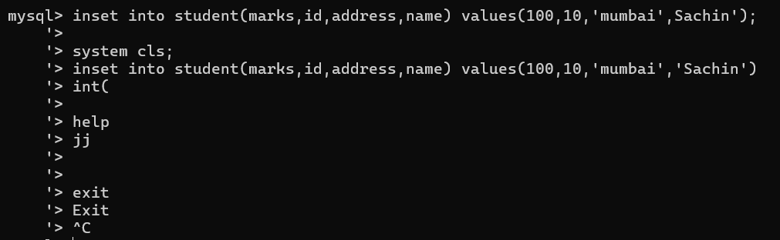

**This is the write way to insert:-**

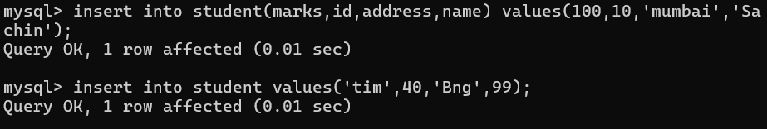

**User can also insert multiple value in direct way 🡪**

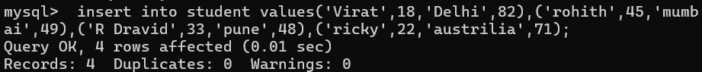

**Data stored inside the table & you wanted to see the table then we will use (SELECT QUERY)**

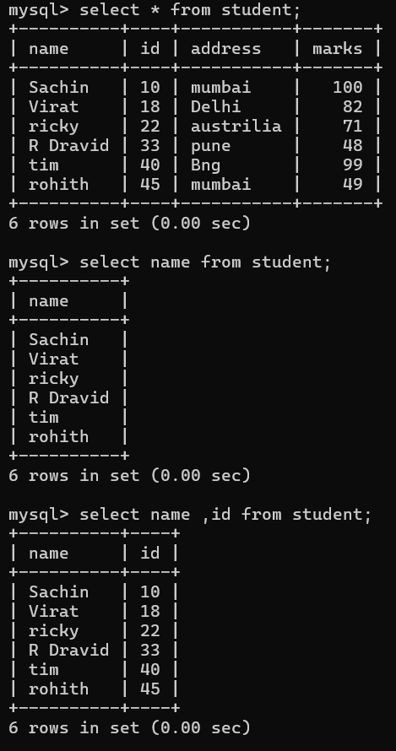

**User need to see the record WHERE id =12 & 3 type of select statement**

**Select the entire table || select the column || select the raw by condition or WHERE clause**

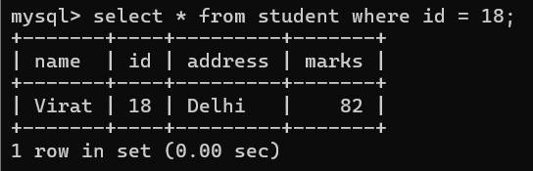

**Once you make ID as primary key you can’t insert any value & it will be always unique. ID column never duplicate because we make id as primary key**

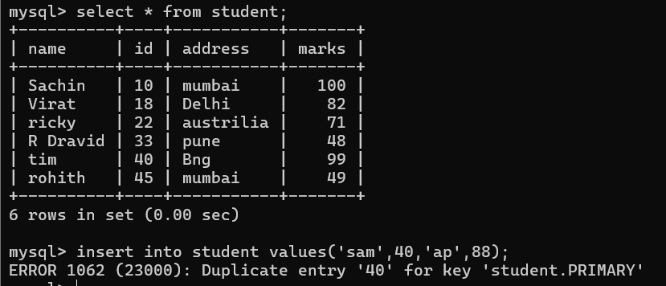

**User want to update wherever you find address as Mumbai want to modify Chennai then (UPDATE)**

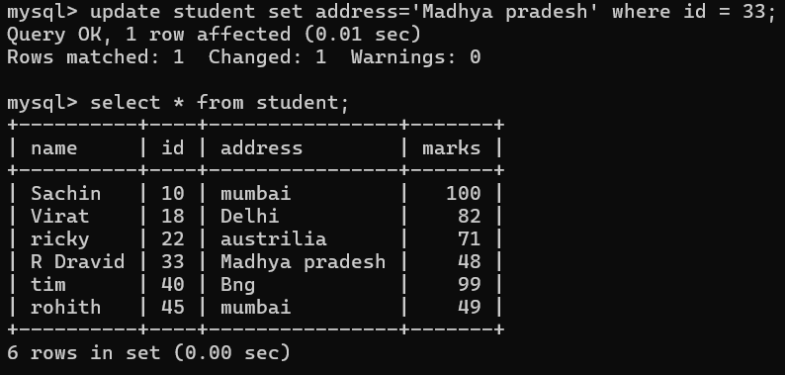

**If user want to add any column in existing table 🡪 (ALTER) but everything is added with null**

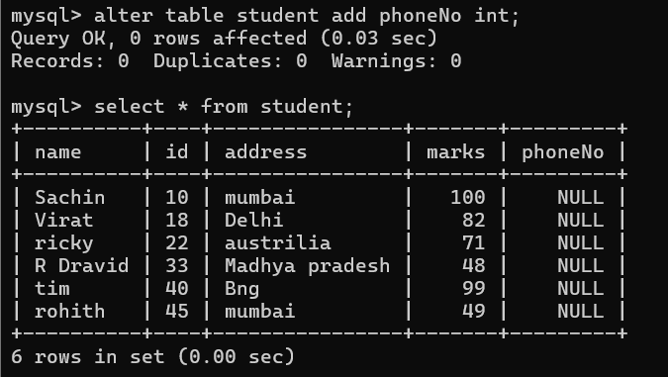

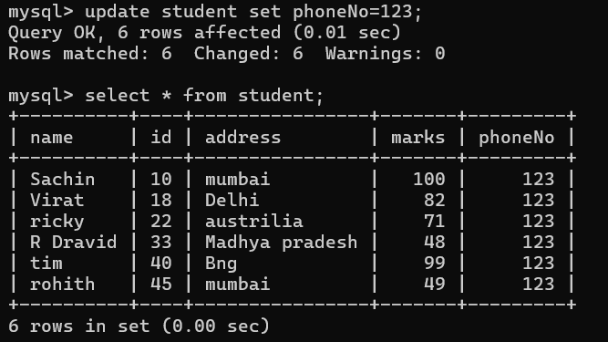**User want to change specific phoneNo then you need to write the condition**

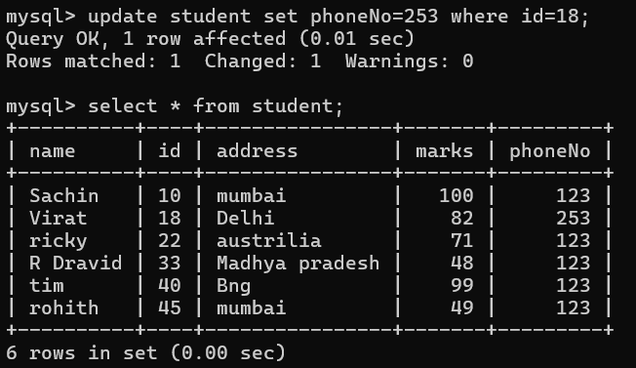

**Want to change the column type –**

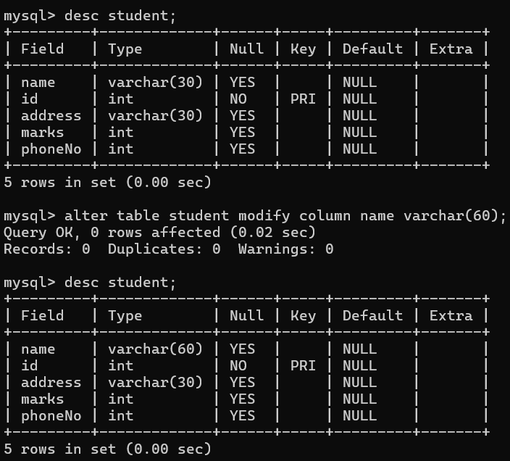

**User can drop the column name from the table as well**

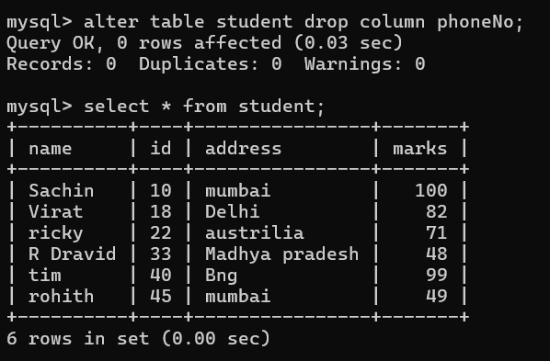

**DELATE ANY DATA – DML command & Changes any structure – DDL COMMAND**

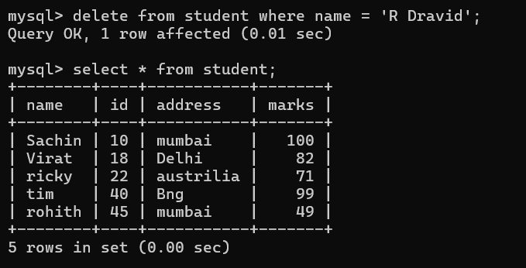

**Lets introduce to sql functions 🡪**

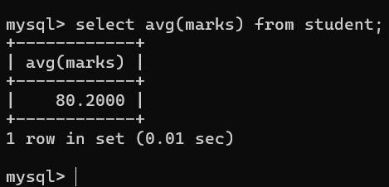

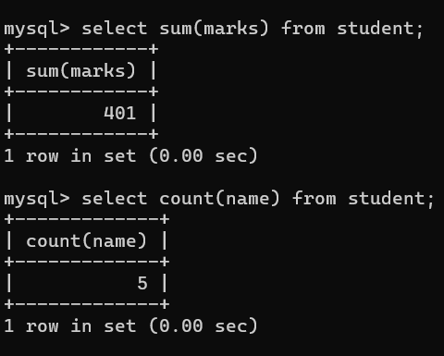

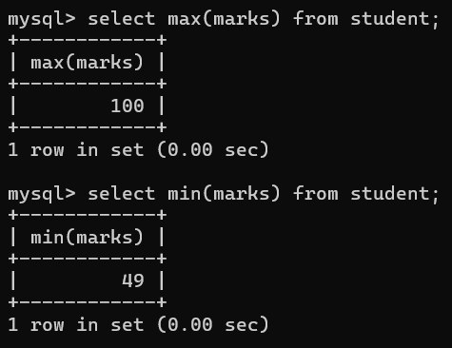

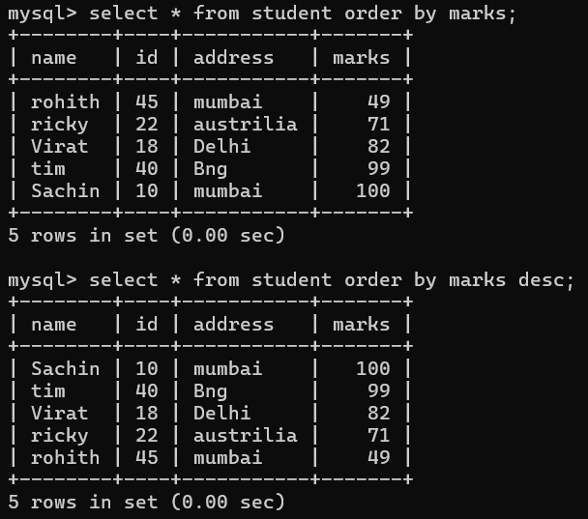

**Wild card character 🡪**

**Student name which start with a then you need to use wild card character**

**Pull out the records of student name which start with a (‘a%’) & names which end with y then’%y)**

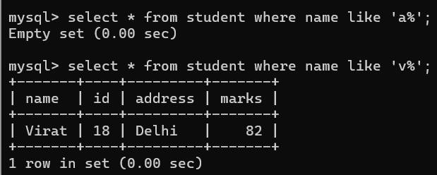

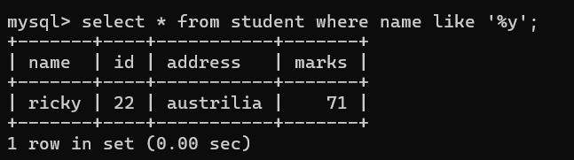

**Pull out the records where second alphabet is ‘a’ then use 2nd wildcard**

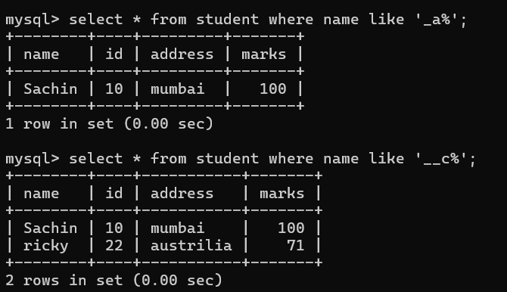

**Pull out the records where second last alphabet is ‘s’ then use below query**

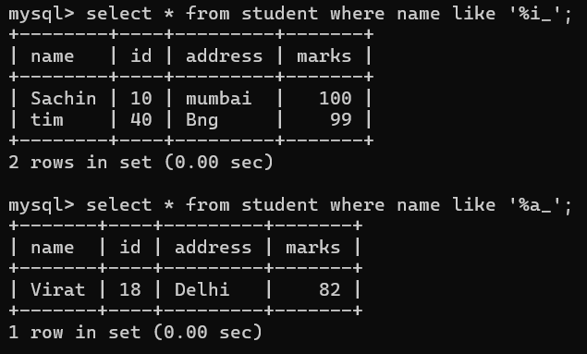

**Lets create another table to make joins –**

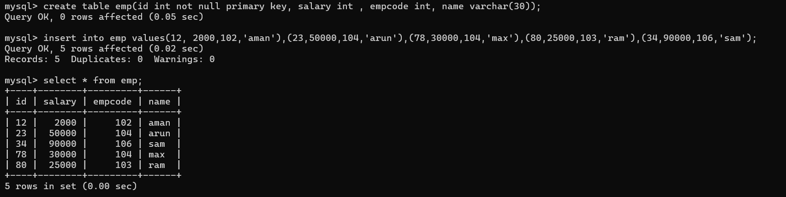**Now user has 2 table under nit database || Innerjoin – it will display the common records**

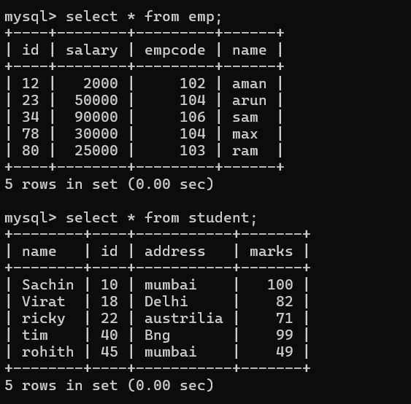

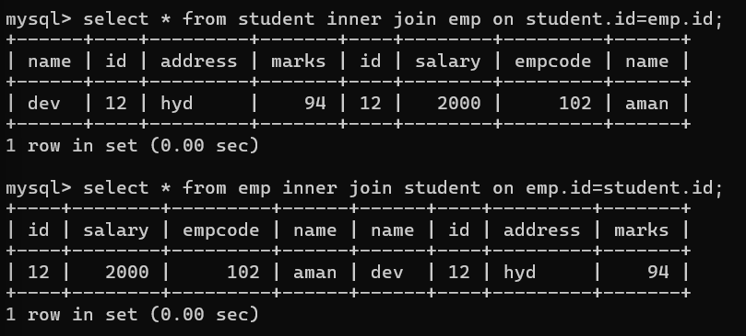

**LEFT JOIN (LEFT OUTER JOIN)🡪**

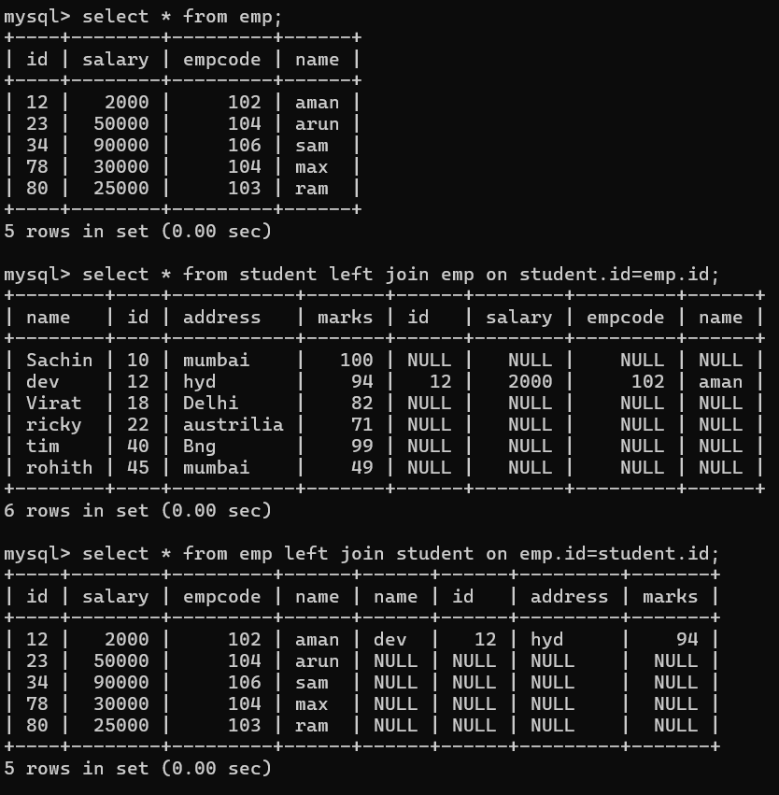

**RIGHT JOIN (RIGHT OUTER JOIN)🡪**

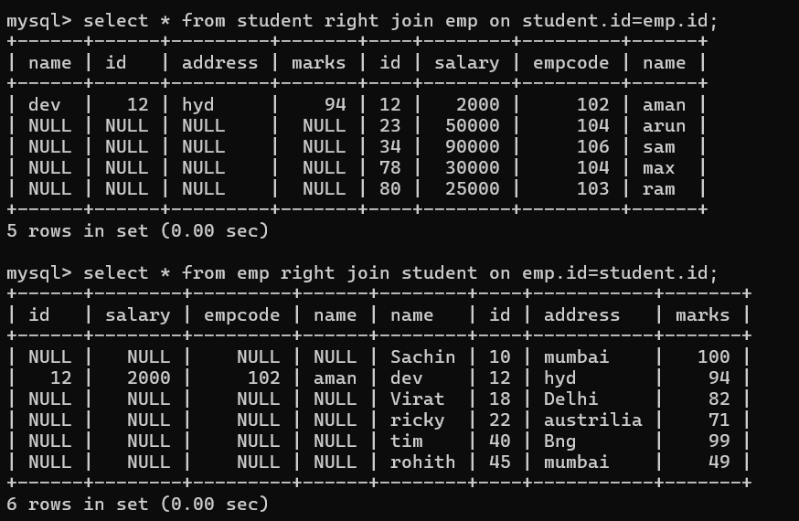

**CROSS JOIN 🡪**

